**Electronics 2**

**27.11.2015**

**Lab 3 report**

**MOS Differential Amplifier**

**Members:**

* Akibur Rahman
* Alexios Sidiropoulos

**Task 1:**

Set up a differential amplifier according to the circuit diagram.

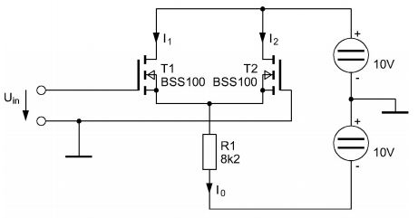

Measure the currents I0, I1 and I2 without input signal (Uin = 0).

Measure the Gate-Source-voltages UGS1 and UGS2.

Check the node equation and calculate the Offset-voltage.

By measuring we got the following:

Currents:

**I0 = 1.12 mA**

**I1 = 0.88 mA**

**I2 = 0.25 mA**

Voltages:

**UGS1 = 0.73 V**

**UGS2 = 0.73 V**

The node equation is:

The ideal case would be I0 = I1 + I2 = 0.88 + 0.25 = 1.13 mA. If we compare the I0 we measured with the calculated I0 we can see a small discrepancy of 0.01.

We can find the offset-voltage by measuring the distance between the Y-axis and the intersection of the two current plots in Task 2, using a ruler and the scale used to plot the graphs.

Our offset voltage is 0.075.

**Task 2:**

Measure the transfer-functions I1 = f(Uin) and I2 = f(Uin) using an XY-recorder

for the voltage range -1 V< Uin < +1 V.

Determine the mutual conductance gm by means of your transfer-characteristic.

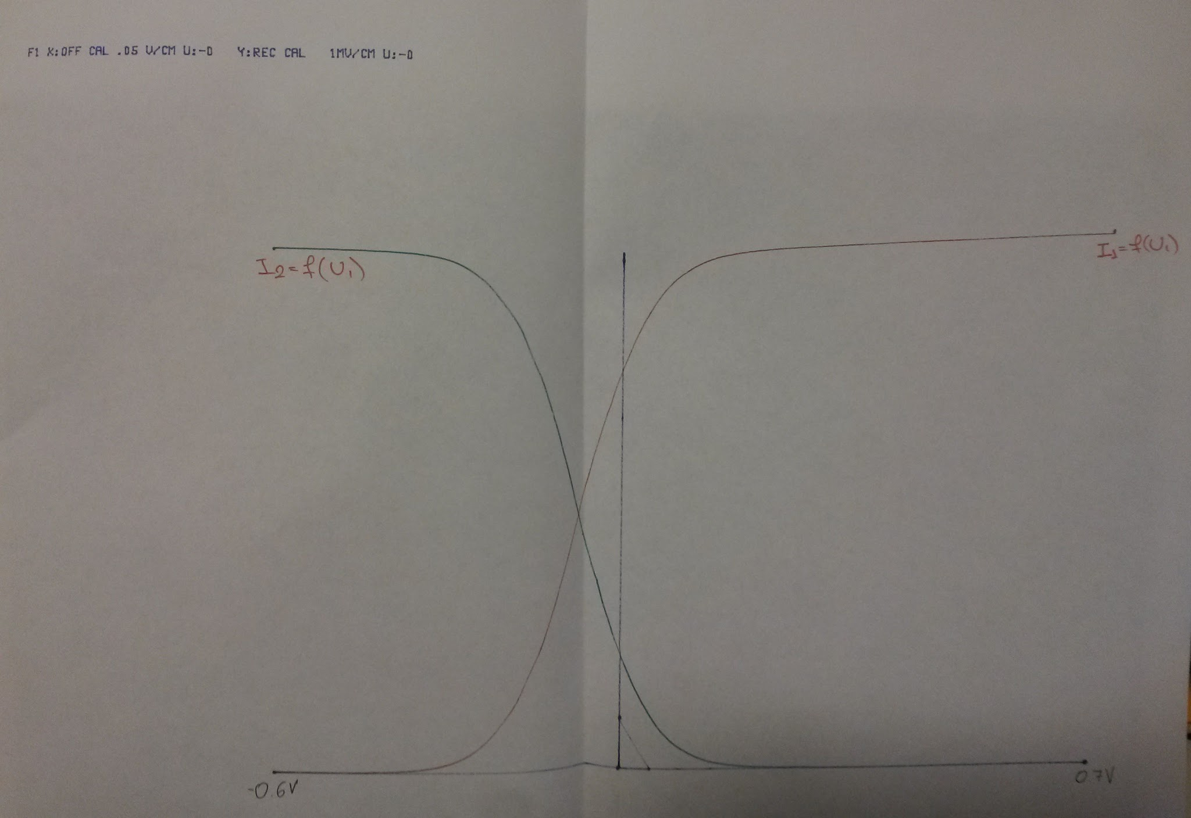

By our plot above, using a ruler and the scale printed on the top left corner of our plot, we get

ΔI = 17.5 mA.

Using the formula for mutual transconductance we have :

gm == 8.75 mS

**Task 3:**

Add two load resistors of R = 4.7k to the circuit to form a voltage amplifier.

Measure the voltage gain VDq. (How?)

We measured the voltage gain VDq by replacing the two R = 10 Ω resistors with resistors of value R = 4.7 Ω. Then we connected two probes after the resistor to measure Uin and Uout.

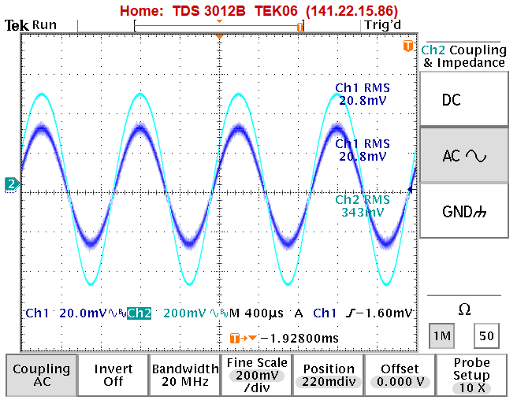

The voltage gain is:

**VDq** = = = 16.5 mV